**Lesson 4 Lesson-End Project**

**Create a new branch and merge the branch in Git**



**Steps to be followed:**

1. Create a new repository
2. Clone the GitHub repository
3. Create a new branch and verify the creation of the new branch
4. Rename an existing branch and list all the branches in your repository
5. Create a new branch and switch to the new branch
6. Create a file and commit the changes
7. Check the status of the new branch
8. Delete the branch and verify the deletion of the branch
9. Switch back to the main branch
10. Merge the branches

**Step 1: Creating a new repository**

1.1 Open the browser in your lab, go to **github.com,** and log in to your account

1.2 Click on the **+** icon from the upper-right corner of the page and select **New repository** from the drop-down menu

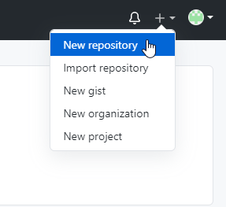

1.3 Enter *lesson-end project* the **Repository name.** Entering **Description** is optional.

1.4 Choose **Public** for the repository type

1.5 Select **Initialize this repository with a README** to include a *README* file for the repository

1.6 Click on the **Create Repository** button

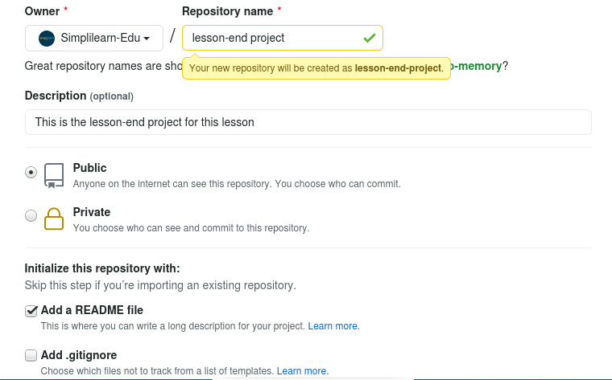

**Step 2: Clone the GitHub repository**

2.1 Open the browser in your lab, Go to **github.com,** and log in to your account

2.2 Open the **lesson-end-project** repo and click on the **Code** button

2.3 Click on the icon as shown in the following image to copy the **URL** provided under **HTTPS**

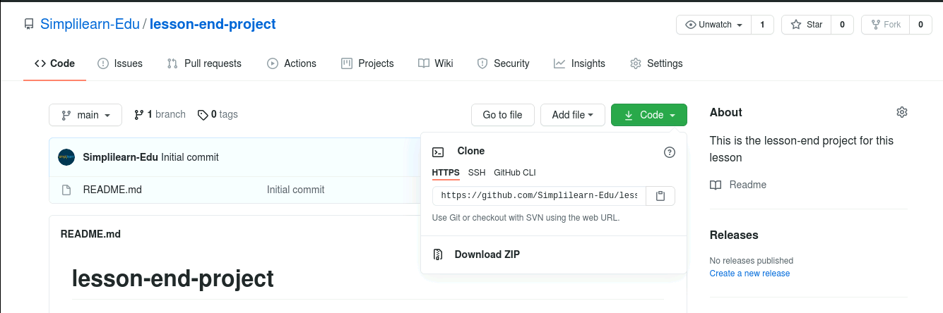

2.4 Open the **Terminal** tab on your lab and use the following command to clone the repository:

**$ git clone URL**

**Note:** Replace URL with the copied URL from the repository

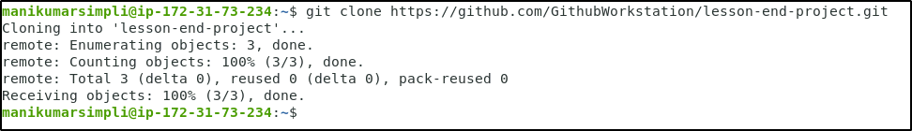

**Step 3: Create a new branch and verify the creation of the new branch**

3.1 Navigate to the **lesson-end-project**

***cd lesson-end-project***

3.2 Use the following command to create a new branch in your repository:

***git branch project_branch***



3.3 Verify the creation of the new branch

***git branch***

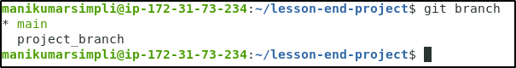

**Step 4: Rename an existing branch and list all the branches in your repository**

4.1 Use the following command to rename the new_branch:

***git branch -m project_branch1***

4.2 Use the following command to list the branches to verify the new name of the branch:

***git branch***

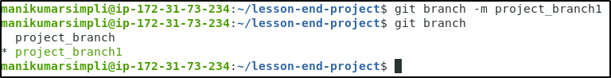

**Step 5: Create a new branch and switch to the new branch**

5.1 Execute the following command to create a new branch:

***git branch project_branch2***

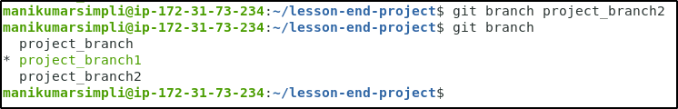

5.2 Use the following command to switch to the newly created **project_branch2**:

***git checkout project_branch2***

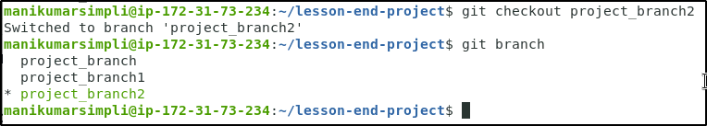

**Step 6: Create a file and commit the changes**

6.1 Use the following command to create a file:

***vi index.html***



6.2 Add the following code in the **index.html** file  
  
 **<html>**

**<body>**

**<p> This is a lesson end project. </p>**

**</body>**

**</html>**

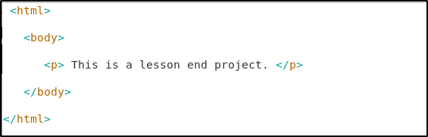

**Note:** Press **Esc** button and enter **:wq** to save the file.

6.3 Use the following commands to add the file to the **project_branch2** and commit the changes:

***git add index.html***

***git commit -a -m "file modified"***

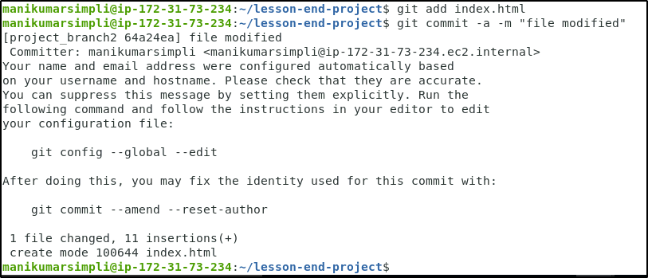

**Step 7: Check the status of the new branch**

7.1 Check the status of the new branch using the following command:

***git status***

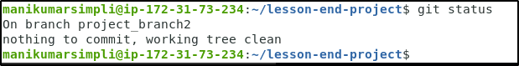

**Step 8: Delete the branch and verify the deletion of the branch**

8.1 Use the following command to delete the newly created branch:

***git branch -d project_branch***



8.2Verify the deletion of the branch

***git branch***

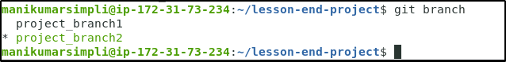

**Step 9: Switch back to the main branch**

9.1 Use the following command to switch back to the main branch:

***git checkout project_branch1***



**Step 10: Merge the branches**

10.1 Use the following command to merge the test_branch to the main branch:

***git merge project_branch2***

